County Durham Foodbank
Today in County Durham there are families struggling to put food on the table. For people on low incomes, a sudden crisis – redundancy, benefit delay or even an unexpected bill- can mean going hungry. Every day parents skip meals to feed their children and people are forced to choose between paying the rent and eating. County Durham foodbank provides emergency food to local people in crisis through a network of 27 distribution points.

The key word for 2015 at the foodbank was partnership.
After a few years of rapid expansion, 2015 was a year of consolidation for the foodbank. Another 5 distribution points were opened, whilst the strategic decision was taken to close some of the quietest distribution points.
Attention turned to how the foodbank team could enhance what was offered at the foodbank, in terms of facilities and support. We were delighted to be given the opportunity to collect short dated fresh products from Greggs and local Sainsbury’s stores, and give out these items from the distribution points.
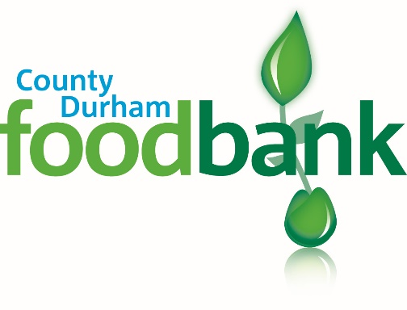Another new partnership was formed with NEPACS (who work to support a positive future for prisoners and their families) and the County’s Community Rehabilitation Teams ​to establish a national voucher system for prisoners being released from prison and families visiting prisons in County Durham. Vouchers can be issued in these prisons and visitors centres and redeemed at any Trussell Trust foodbank nationally.

Our primary purpose of course continues to be the provision of food to those in a crisis situation. Last year, the foodbank distributed enough food to provide nearly 15,000 people with food for 3 days. This would not be possible without the incredibly faithful support of some many people donating food items. A huge thank you must go to those who organise collections at their churches, schools, places of work or community groups, without whom the foodbank could not continue.
Heat or Eat?
In April 2015, npower launched ‘Fuel Bank’, its initiative to help foodbank users with pre-payment meters by offering them vouchers for gas or electricity. The first of its kind, the project aimed to offer help to those being forced to choose between ‘heating and eating’.

Durham Christian Partnership worked closely with the fuel poverty charity National Energy Action and npower to develop the scheme, and were the first food bank in the UK to start issuing the vouchers to people referred to the foodbank.
“Thank you so much for all your help and support - you are a true tonic for a weary soul.”

